Use ‘Microsoft ODBC Administrator’ (32-bit version: C:\Windows\SysWOW64\odbcad32.exe) to create a DSN for your MariaDB database. Leave all the option checkboxes blank/unchecked.
In a new Excel file, select cell A1, then click Data->From Other Sources -> From Data Connection Wizard
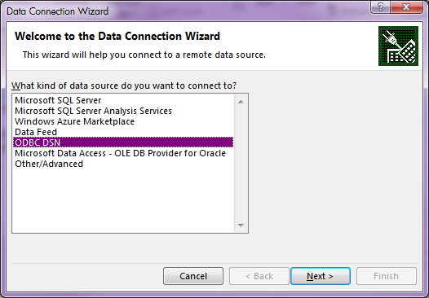
Select “ODBC DSN”, click Next
Select the ODBC Source you just created, click Next.
Select the table “show_truncation”, click Next
Click Finish in the “Save Data Connection File and Finish” dialog.
Click OK to insert the data into a cell of the spreadsheet.
Notice the values in column C (“LABEL”) are truncated:
- the “ABCDEFGHIJKLMNO” value only shows ABCDEFG
- the Z is completely missing
- YX shows only Y
- PQRS shows only PQ.
The ID, LOAD_TIME and A_NUMBER are OK.
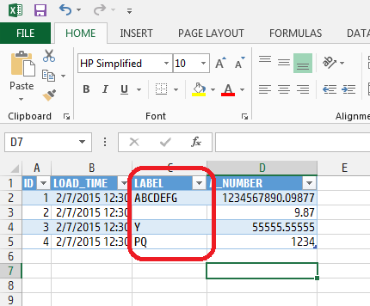
In Excel, select the “Design” tab (if not already there).
Click the down-arrow below “Refresh” (in “External Table Data” section of the ribbon), select “Connection Properties”.
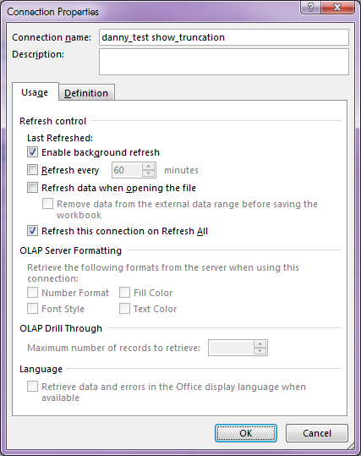
Click on the Definition tab.
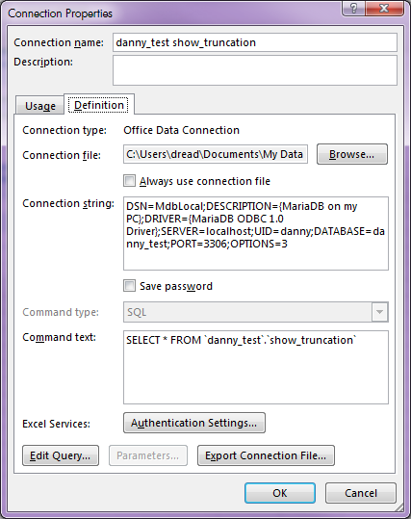
Click “Edit Query…”
When the warning dialog appears (“This query cannot be edited by the Query Wizard”), click OK.
‘Microsoft Query” window appears, and shows the full values in the label column!
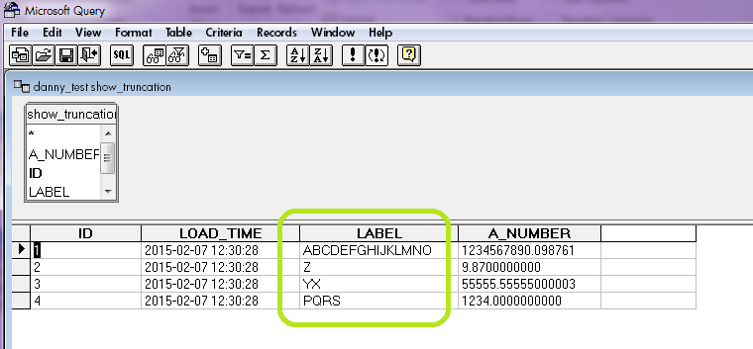

Mysterious to me!

